**QUESTION 1**

**ShopNest Store Capstone**

100 marks

**Resources**

ShopNest stands as the leading department store in the e-commerce marketplaces in Portugal. Serving as a seamless link, it connects small businesses from various regions in Portugal to channels, streamlining the process with a single point of contact. Through the ShopNest Store, these merchants can showcase and sell their products, with the added convenience of direct shipment to customers facilitated by ShopNest logistics partners. The provided data represents authentic commercial information that has undergone the process of anonymization.

This capstone has 9 datasets and the descriptions are below :  
  
**Customers_dataset :**

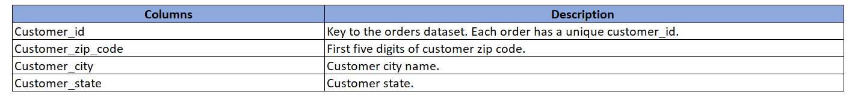

**Geolocation_dataset :  
**

**Order_items_dataset :  
**

**Order_payments_dataset :  
**

**Order_reviews_dataset :  
**

**Orders_dataset :  
**

**Products_dataset :  
**

**Sellers_dataset :**

**  
Product Categories :**

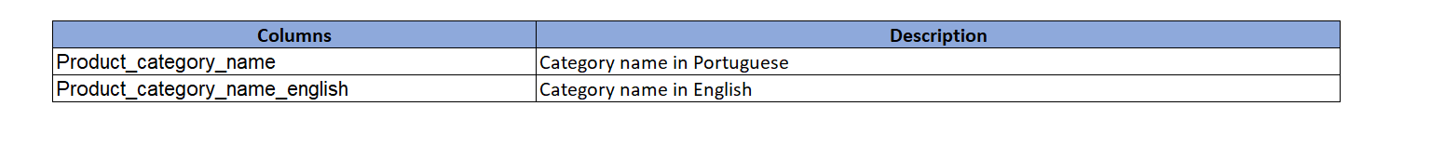

**Tasks to do :**Design a comprehensive Power BI dashboard to address key business analytics for a retail dataset. The following analytical questions should be answered through your dashboard:

1. **Top Categories by Total Price:**

Identify and visually represent the top 10 product categories by total sales.

1. **Delayed Orders Analysis:**

Determine the number of delayed orders in each category. An order is considered delayed if the actual delivery date is later than the estimated delivery date.

1. **Monthly Comparison of Delayed and On-Time Orders:**

Create a dynamic visual that compares the number of delayed orders to the number of orders received earlier for each month. Utilize the drillthrough cross-report feature to provide a detailed analysis of late and on-time deliveries.

1. **Payment Method Analysis:**

Analyze the most frequently used payment methods by customers using a visually appealing representation, such as a pie chart or other suitable visuals.

1. **Product Rating Analysis:**

Determine the top 10 highest-rated products and the bottom 10 lowest-rated products using a bar or column chart.

1. **State-wise Sales Analysis:**

Identify and visually represent states with high and low sales, providing a clear understanding of regional sales performance.

1. **Seasonal Sales Patterns:**

Investigate and visualize any seasonal patterns(Quarterly) or trends in sales data over the course of the year.

1. **Revenue Analysis:**

Determine the total revenue generated by ShopNest Store  and analyze how it changes over time(Yearly). Represent this information through suitable visuals to highlight trends and patterns.